1. Conjunto de cadenas de longitud mayor a 0 sobre {x, y} tales que, si comienzan con **y**, deben terminar con **x**.

x(x|y)* | y(x|y)*x

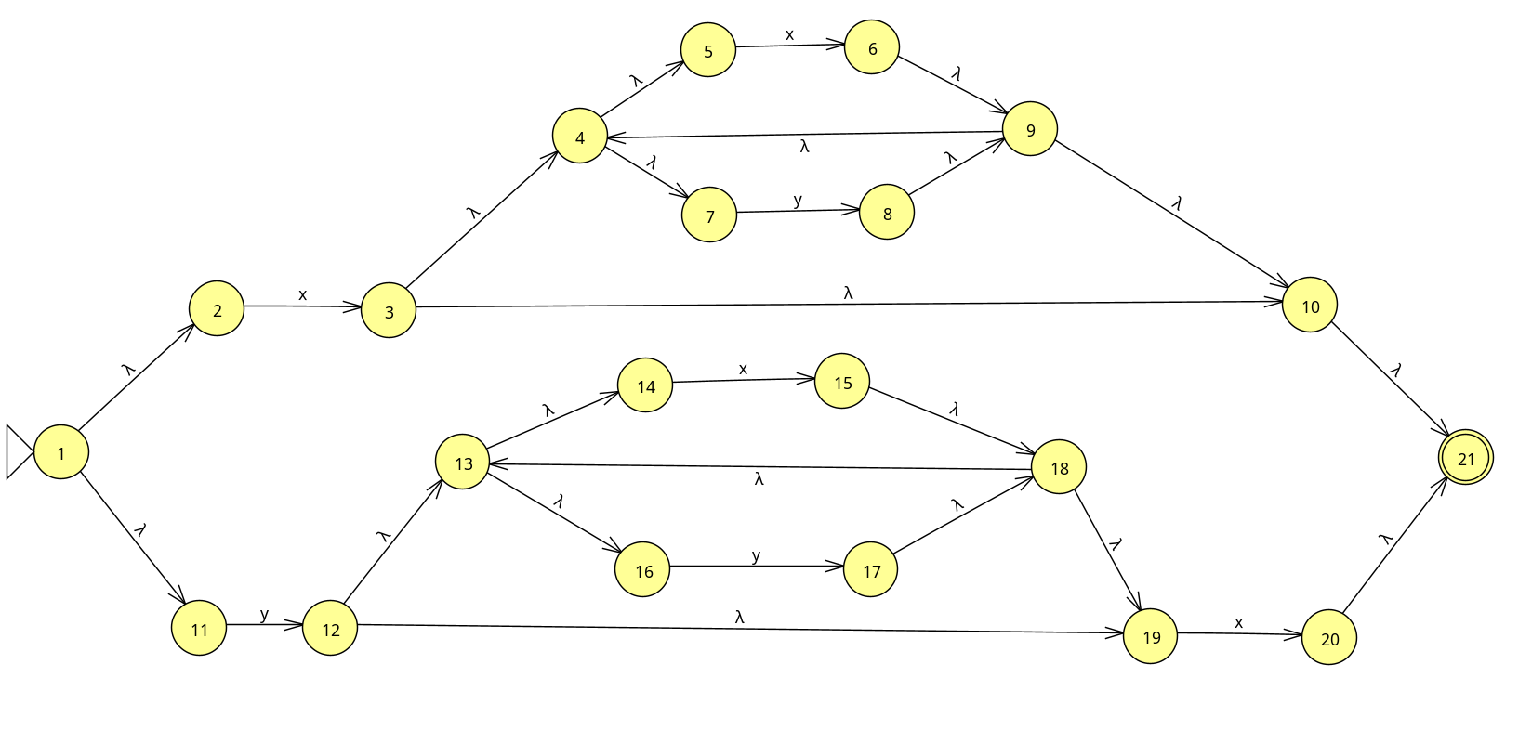

e-clausura({1}) = {1,2,11} A (inicial)  
Mueve(A,x) = {3}

Mueve(A,y)={12}

e-clausura({3})={3,4,5,7,10,21} B (final)

e-clausura({12})={12,13,14,16,19} C

Mueve(B,x)={6}

Mueve(B,y)={8}

Mueve(C,x)={15,20}

Mueve(C,y)={17}

e-clausura({6})={4,5,6,7,9,10,21} D (final)

e-clausura({8})={4,5,7,8,9,10,21} E (final)

e-clausura({15,20})={13,14,15,16,18,19,20,21} F (final)

e-clausura({17})={13,14,16,17,18,19} G

Mueve(D,x)={6} D

Mueve(D,y)={8} E

Mueve(E,x)={6} D

Mueve(E,y)={8} E

Mueve(F,x)={15,20} F

Mueve(F,y)={17} G

Mueve(G,x)={15,20} F

Mueve(G,y)={17} G

| Mueve | x | y |
| --- | --- | --- |
| A | B | C |
| B | D | E |
| C | F | G |
| D | D | E |
| E | D | E |
| F | F | G |
| G | F | G |

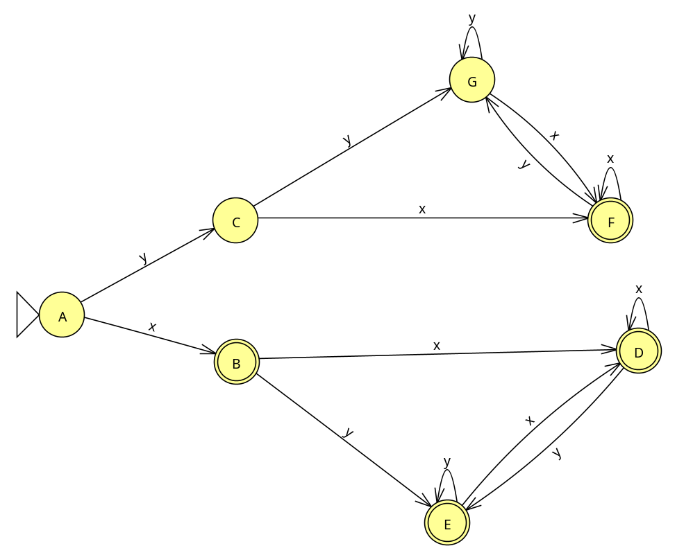

S1={A,C,G}

S2={B,D,E,F}

| S1 | x | y |
| --- | --- | --- |
| A | S2 | S1 |
| C | S2 | S1 |
| G | S2 | S1 |

| S2 | x | y |
| --- | --- | --- |
| B | S2 | S2 |
| D | S2 | S2 |
| E | S2 | S2 |
| F | S2 | S1 |

S1={A,C,G}

S2={B,D,E}

S3={F}

| S1 | x | y |
| --- | --- | --- |
| A | S2 | S1 |
| C | S3 | S1 |
| G | S3 | S1 |

| S2 | x | y |
| --- | --- | --- |
| B | S2 | S2 |
| D | S2 | S2 |
| E | S2 | S2 |

S1={A} (inicial)

S2={C,G}

S3={B,D,E} (final)

S4={F} (final)

| S2 | x | y |
| --- | --- | --- |
| C | S4 | S2 |
| G | S4 | S2 |

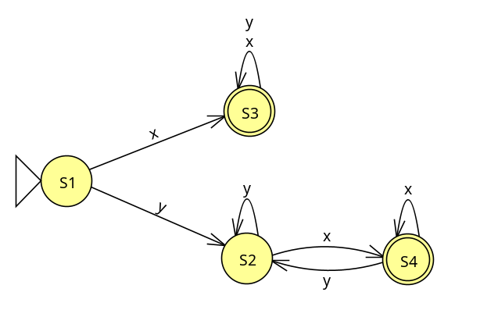

1. Conjunto de cadenas sobre {a, s} que no posean dos **s** o dos **a** consecutivas.

(sa)* | (as)*

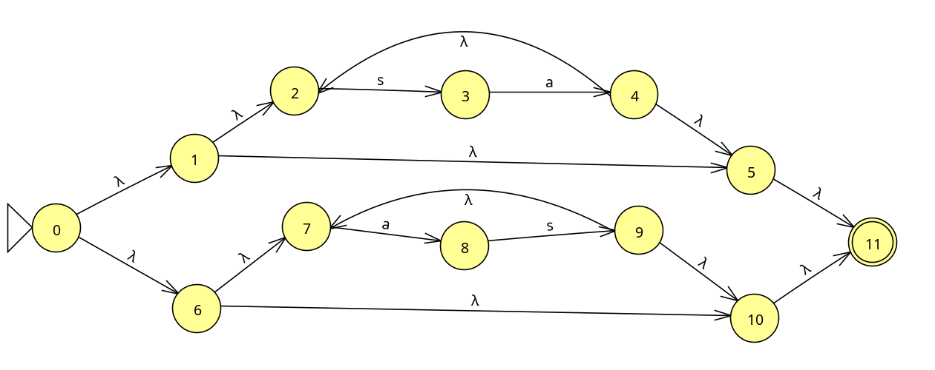

e-clausura({0})={0,1,2,5,6,7,10,11} A

Mueve(A,s)={3}

Mueve(A,a)={8}

e-clausura({3})={3} B

e-clausura({8}={8} C

Mueve(B,s)={} M

Mueve(B,a)={4} D

Mueve(C,s)={9} E

Mueve(C,a)={} M

e-clausura({})={} M

e-clausura({4})={2,4,5,11} D

e-clausura({9})={7,9,10,11} E

Mueve(M,s)={} M

Mueve(M,a)={} M

Mueve(D,s)={3} B

Mueve(D,a)={} M

Mueve(E,s)={} M

Mueve(E,a)={8} C

| Mueve | s | a |
| --- | --- | --- |
| A |  |  |
| B |  |  |
| C |  |  |
| D |  |  |
| E |  |  |
| M |  |  |